**Install CH340 driver in Windows 10**

1. **Open the driver file**

The installation package of the CH340 driver is provided in our data package, whose location is shown in the figure below. Decompress the file.

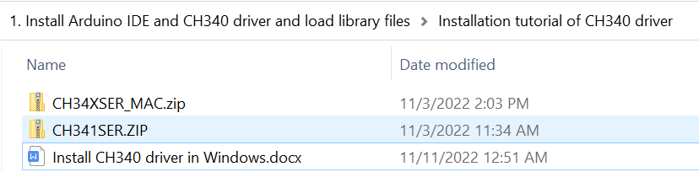

1. **Double click SETUP.EXE**

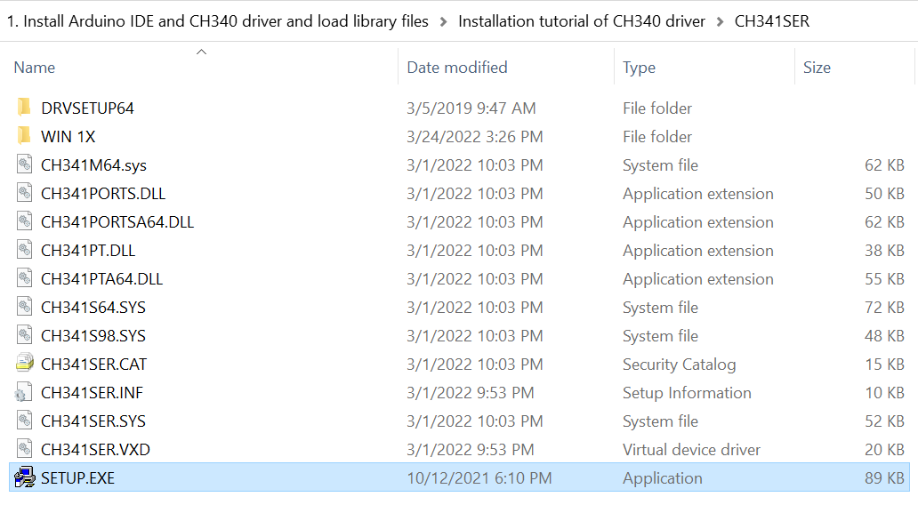

1. **Click to install**

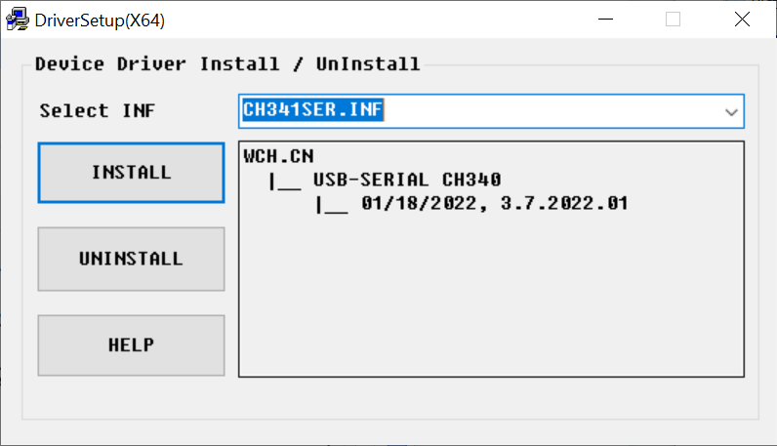

1. **Installed successfully**

